Part 1:

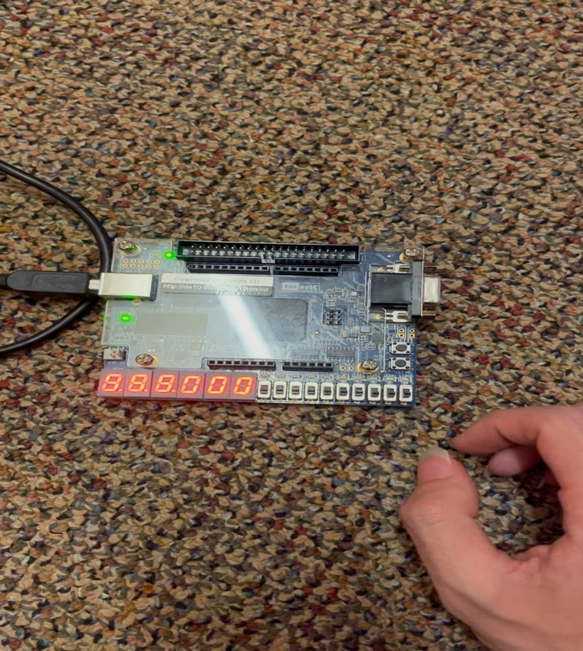I wrote the code for the circuit in the lab diagram.

Part 2:

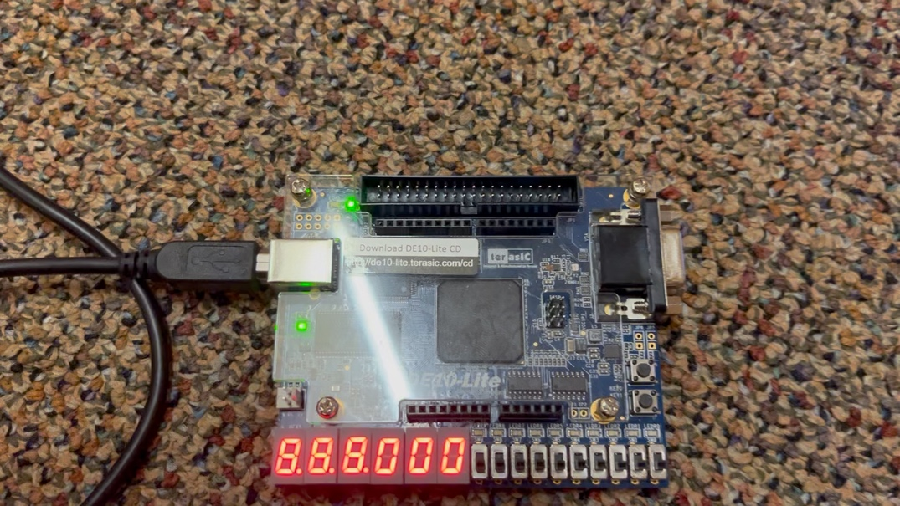For part I copied over and modified the code for the adder with an if statement to subtract based on if a switch was on or off.

Part 3:

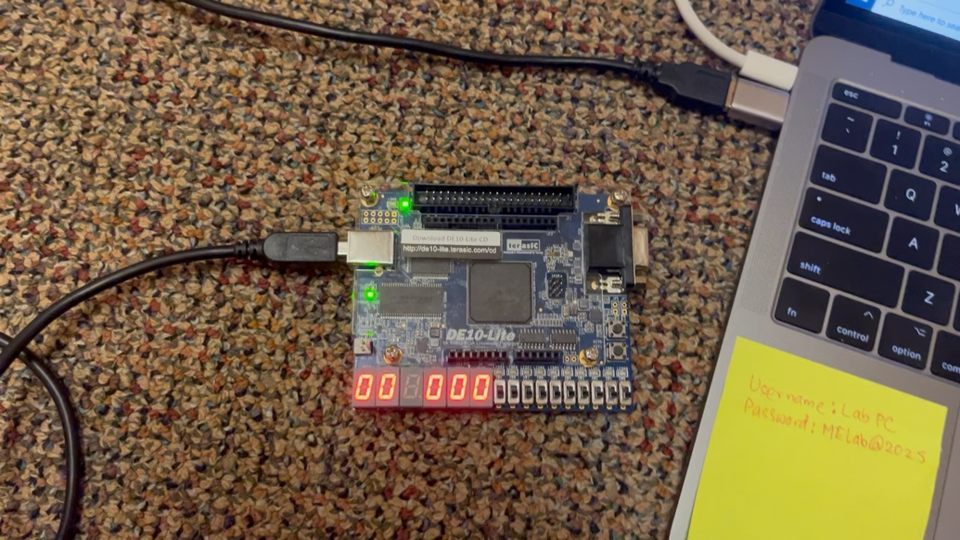For the multiplier circuit I coded a 4-bit ripple carry adder. Then I cascaded four of the ripple carry adders and fed them the parameters from the diagram in the lab instructions.

Part 4:

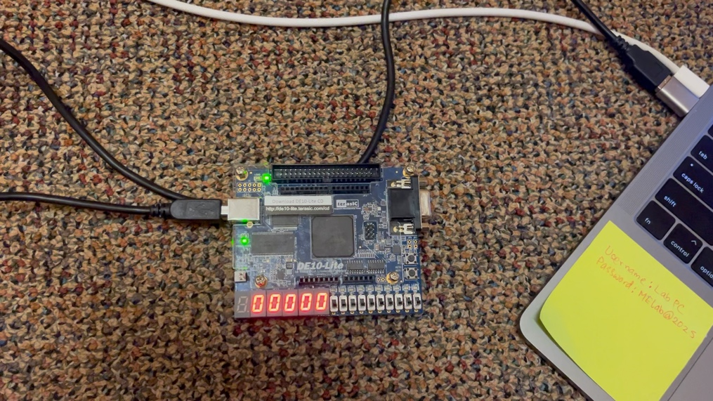I modified the 4-bit ripple carry adder into an 8-bit one. And then I modified the multiplier code to run 8 of them. This took a while to write but once I realized the code was supposed to multiply an input by 100, I was able debug and fix the errors.